Simple Articles
Create a Web page (HTML5 + CSS3 + images) that looks and behaves like the screenshot below:
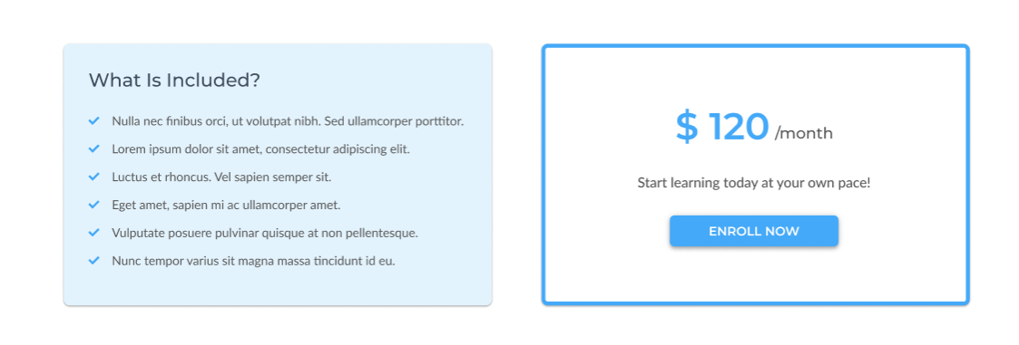
You are given the above screenshots + all required images.

Output
The output should be valid HTML5 + CSS3 + images that implement the above web page.

Constraints
- Use font 'Montserrat' for the heading and the price element
- Use font 'Lato' for the text
- The site should open correctly in the latest version of Chrome
- Pixel-perfect implementation is NOT required

